

**School of Public Administration  
Bachelor of Science in Computing**

**COMP321 Information System Implementation  
Final Report**2015/16 2nd semester

|  |  |
| --- | --- |
| Online Shopping Mall | |
|  |  |
| Team number: | Group 8 |
| Team members: | Douglas Li  Rancho Zhou  Tim Xin  Price Ou  Jack YangClick here to enter text. |
|  |  |
| Supervisor: | Andrew Siu |
| Assessor: | Calana Chan |
|  |  |
| Submission Date: | Apr 14, 2016 |

**Table of Contents**

[1 Introduction 5](#_Toc448444466)

[1.1 Overview 5](#_Toc448444467)

[1.2 Objectives 6](#_Toc448444468)

[2 Background and Related Work 12](#_Toc448444469)

[2.1 Background 12](#_Toc448444470)

[2.2 Related Work 13](#_Toc448444471)

[3 System Design 16](#_Toc448444472)

[3.1 Data Modeling 16](#_Toc448444473)

[3.1.1 Entity-Relationship Diagram 16](#_Toc448444474)

[3.1.2 Data Structure 17](#_Toc448444475)

[3.2 Dynamic Modeling 22](#_Toc448444476)

[3.2.1 State diagram 22](#_Toc448444477)

[3.2.2 Purchase Activity Diagram 24](#_Toc448444478)

[4 System Implementation 25](#_Toc448444479)

[4.1 Platforms 25](#_Toc448444480)

[4.2 Architecture 26](#_Toc448444481)

[4.3 Module Design 26](#_Toc448444482)

[4.4 Project Outcome 27](#_Toc448444483)

[4.4.1 Home page 27](#_Toc448444484)

[4.4.2 Register and log in 28](#_Toc448444485)

[4.4.3 purchasing product 29](#_Toc448444486)

[4.4.4 Vendor Page 32](#_Toc448444487)

[4.5 Testing 38](#_Toc448444488)

[5 Conclusion and Further Work 48](#_Toc448444489)

[5.1 Conclusion 48](#_Toc448444490)

[5.2 Further Work 48](#_Toc448444491)

[References 49](#_Toc448444492)

[Appendix 51](#_Toc448444493)

[Project plan 51](#_Toc448444494)

[Team Members 53](#_Toc448444495)

[Job Distribution 54](#_Toc448444496)

[Function requirement 54](#_Toc448444497)

[Technical specification 54](#_Toc448444498)

[Other jobs 54](#_Toc448444499)

[Peer Assessment Form 55](#_Toc448444500)

Table of Figures

[Figure 1 Entity-Relationship Diagram 17](#_Toc448444501)

[Figure 2 State diagram 24](#_Toc448444502)

[Figure 3 Purchase Activity Diagram 25](#_Toc448444503)

[Figure 4 Abstraction architecture of system 27](#_Toc448444504)

[Figure 5 Home Page 29](#_Toc448444505)

[Figure 6 Register Page 29](#_Toc448444506)

[Figure 7 Log In Page 30](#_Toc448444507)

[Figure 8 Add product to shopping cart 30](#_Toc448444508)

[Figure 9 Change Product Quantity I 31](#_Toc448444509)

[Figure 10 Change Product Quantity II 31](#_Toc448444510)

[Figure 11 Leave commend 32](file://localhost/Users/douglasli/Desktop/00-Final%20Report.docx#_Toc448444511)

[Figure 12 Vendor page 33](#_Toc448444512)

[Figure 13 Add new product 34](#_Toc448444513)

[Figure 14 Detail page for vendor 35](#_Toc448444514)

[Figure 15 Edit information 36](#_Toc448444515)

[Figure 16 Pending to shipped 37](#_Toc448444516)

[Figure 17 out of stock 38](#_Toc448444517)

[Figure 18 Cancel order 39](#_Toc448444518)

[Figure 19 Gantt Chart Part I 52](#_Toc448444519)

[Figure 20 Gantt Chart Part II 53](#_Toc448444520)

[Figure 21 Gantt Chart Part III 54](#_Toc448444521)

# Introduction

This project aims at providing an elegant online shopping experience to tentative customers. The system contains one vendor and multiple potential customers. And the interaction between the two parties can be stated as follows. The vendor displays the products in a manner which is easy for customers to select, place orders, and make purchases. Our online shopping mall provide a platform for sneaker trade. The interaction between vendors and customers can be stated as follows. The vendor provides descriptions and images of their selling sneakers. This website will display that information in a list for customer. Customer can select product items, place orders and make purchases.

The back-end software system will be implemented by using ASP.NET, which offers three frameworks and all three frameworks are stable and mature. In addition, front-end will use JavaScript, html and css.

## Overview

This project aims at providing an elegant online shopping experience to tentative customers. The system contains one vendor and multiple potential customers. And the interaction between the two parties can be stated as follows. The vendor displays the products in a manner which is easy for customers to select, place orders, and make purchases. Our online shopping mall provide a platform for sneaker trade. The interaction between vendors and customers can be stated as follows. The vendor provides descriptions and images of their selling sneakers. This website will display that information in a list for customer. Customer can select product items, place orders and make purchases.

The back-end software system will be implemented by using ASP.NET, which offers three frameworks and all three frameworks are stable and mature. In addition, front-end will use JavaScript, html and css.

## Objectives

All the functions we desire to implement are listed below.

The front page of the shopping mall shows a **product list**.

* (A1) A customer may browse products in a list of products. The list shows basic information of products, including product name, brand, price and a thumbnail image. Each product belongs to one of the pre-defined brands
* (A2) The product list supports **paging**. The customer can navigate the product list by ‘page up’, ‘page down’ and jumping to a specific page. Paging works properly after applying filter or sorting listed below.
* (A3) The customer can **filter** the product list **by brand**. He/she can also list products of all brands.
* (A4) The customer may filter the product list by **searching keywords** in product name. This function work correctly with the brand filter.
* (A5) The customer may **sort** the product list **by price**.

**The product detail page** shows detail information about one product.

* (A6) The customer may select a product in the product list to go to the product detail page. The product detail page shows information for one product, which includes the product name, brand, price and a thumbnail image. In addition, the product detail page also shows detail description as a list of at least two properties. For example, the product detail page for a book may show authors, ISBN, publisher, release date and number of pages.
* (A7) The product detail page supports display of **one or more detail photo** of the selected product.

The system has basic **account management** for customers.

* (B1) A customer may **register a new account**. He/she has to provide full name, email address, password and shipping address. After registration, the user is logged in automatically.
* (B2) A customer may **log in** and **log out**, and the interface shows the name of the current user. The product list and product detail page are accessible to customers without login. On the other hand, the shopping cart and purchase tracking are only accessible after login.
* (B3) The customer can **change password**. There is strength requirement for password. The password should contain at least 6 characters, in which there are at least 1 digit and 1 capital letter.
* (B4) If a customer tries to add a product to the shopping cart on the product detail page without first logging in, the system **redirects** the user **to the login page**. After successful login, the system redirects the user back to the original product detail page.
* (B5) The server only saves hash values of customers’ passwords. Passwords are never saved in plain text in the server.

To make any purchase, a customer must add products to his/her shopping cart. The customer can check out all items in the cart to place an order.

* (C1) The customer adds a product to his/her shopping cart by clicking a button in the product detail page. The quantity to buy is assumed to be 1. The items in shopping cart are persisted across user sessions. Next time the customer logs in, he/she can still see the items in the shopping cart.
* (C2) The customer can list the products in his/her shopping cart in a shopping cart page. In this page, the entry for each product shows the product name, price and the quantity to buy. The page also shows the total order amount (i.e. how much the customer has to pay in total) in the shopping cart. The customer can click an item in the shopping cart to go to the product detail page of the entry.
* (C3) The customer can press a button in the shopping cart page to check out all items in the shopping cart. This action creates a purchase order with a newly allocated unique P.O. number, and clears the content of the cart. After checkout, the system shows the purchase order detail page of the newly created purchase order. (refer to requirement D3).
* (C4) The shopping cart page allows the customer to change the quantity of an item. This allows the customer to order more than one piece of a product (e.g. buy two copies of a book).
* (C5) The customer can remove an item from the shopping cart.
* (C6) If the customer adds a duplicate product to the shopping cart, the application will give a warning message and does not change the content of the shopping cart.

Purchase tracking: After placing an order, the customer can trace the processing status of the order in a purchase tracking page. For simplicity, we assume that each purchase order is fulfilled in a single shipping package. The purchase order status describes the various stages of order processing. Possible values include ‘pending’, ‘shipped’, ‘hold’, and ‘cancelled’.

* (D1) The purchase tracking page lists the purchase orders that the customer has placed. This page shows the following for each purchase order: The P.O. number, the purchase date, the total order amount and the purchase order status. The purchase orders are displayed in reverse chronological order of purchase date. When the customer clicks an entry in the list, he/she can see the detail in a purchase order detail page.
* (D2) The customer can filter the list of purchase orders in two ways. First, the page only shows ‘current purchases’ with status ‘pending’ and ‘hold’. Second, the page only shows ‘past purchases’ with status ‘shipped’ and ‘cancelled’.
* (D3) The purchase order detail page shows the P.O. number, the purchase date, the customer name, the shipping address, the total order amount and the purchase order status. If the order is shipped, this page shows the shipment date. If the order is cancelled, the page shows the order cancel date and who (customer or vendor) cancels the order. The page also includes, for each product in the purchase order, the product name, the quantity, the unit price and the subtotal.
* (D4) Before a purchase order is shipped, the customer can cancel the order. This can be done by clicking a button in the purchase order detail page. This action will change the status of the purchase order to ‘cancelled’. Note that this action is only available for purchase orders in the status ‘pending’ or ‘hold’.

The vendor maintains a product catalog in the shopping mall. He/she can also process purchase orders from customers. Because there is only one vendor, the system only needs to implement a single vendor user account. No account management of vendor accounts is necessary in this project. The application provides the following functions.

Product catalog maintenance: The vendor can browse the product catalog, edit some properties of a product, and add new products.

* (E1) The vendor may browse the product catalog in an interface similar to product list for customers. (Refer to requirements A1, A2, A3 and A6). The vendor is not a customer, and no shopping cart or ‘add to cart’ button should be shown.
* (E2) The vendor can find products by searching keywords in product names. He/she can also find a specific product by entering a unique product ID.
* (E3) The vendor may add a new product to the catalog. The vendor enters basic information of the product, including product name, brand, price and a thumbnail image. He/she can enter detail information of the new product as a list of properties. (Refer to requirement A6)
* (E4) In addition to the thumbnail image, the vendor can upload 1 to 4 detail photos for a product. These photos are usually of higher resolution and are displayed in the product detail page in a user-friendly interface. (Refer to requirement A7)
* (E5) The vendor can edit information of a product in a product detail page. He/she can change the product name and product brand. He/she can also change detail information as a list of properties. (Refer to requirement E3).
* (E6) The vendor can change the thumbnail and detail photos for a product. He can add or remove photos.

Purchase order processing: The vendor can list purchase orders by different status. He/she may ship, hold, or cancel a purchase order in the purchase order processing page.

* (F1) The purchase order list page lists purchase orders received by the application. It shows the P.O. numbers, purchase dates, customer names, total order amounts and purchase order status. The purchase orders are sorted in descending order of purchase date. The vendor can click an entry to open a purchase order processing page.
* (F2) The vendor can filter the purchase order list in three ways. He/she can show only the ‘pending orders’ (with status ‘pending’). He/she can show only the ‘orders on hold’ (with status ‘hold’). Finally, the vendor can select to show ‘past orders’ (with status ‘shipped’ or ‘cancelled’).
* (F3) The purchase order processing page shows similar information as the purchase order detail page (refer to requirement D3). In addition, the vendor can click a button to ship a purchase order. This action changes the status of the purchase order from ‘pending’ to ‘shipped’ and starts the shipping process.
* (F4) The vendor can enter a P.O. number to view and process a specific purchase order.
* (F5) In the purchase order processing page, the vendor can click a button to hold a purchase order. This is useful, for example, if some product in the purchase order is temporarily out-of-stock. This action is only available when the status of the purchase order is ‘pending’, and this action changes the status to ‘hold’.
* (F6) In the purchase order processing page, the vendor can click a button to unhold and ship a purchase order. This action changes the status of the purchase order from ‘hold’ to ‘shipped’ and starts the shipping process.
* (F7) In the purchase order processing page, the vendor can click a button to cancel a purchase order. This is useful, for example, to inform the customer that the ordered products are no longer available. This action is only available for purchase orders in the status ‘pending’ or ‘hold’. This action changes the status of the purchase order to ‘cancelled’.

These advanced features are also designed and implemented.

* (Z1) The vendor needs to analyze the sales of the products and find out the best selling products. The report measures sales by both sales quantities (number of items sold) and sales amount (the dollar amount received in sales). The default reporting period is the last 30 days, but the vendor may also customize the reporting period.
* (Z2) Design a notification feature to make it to easier for a customer to track the change of status of purchase orders. For example, when the vendor ships a purchase order, the customer will receive a notification message. The interface should distinguish between read and unread notifications.
* (Z3) A customer can express his/her satisfaction of a product with customer’s rating. A customer who has purchased a product successfully can rate it on a scale of 1 to 5 stars after the purchase is shipped. Decide whether a customer can rate one product more than 1 times, and whether he/she can change the ratings afterwards. The product detail page shows customers’ average rating as a decimal number (e.g. 3.5 stars). Pay special attention when number of ratings is smaller (e.g. less than 2). Consider how to use the average ratings in product list for customers and the vendor.
* (Z4) In addition to star ratings, customers also want to write short reviews for products in the shopping mall. Design a feature to allow a customer to write short review for a product. Consider how to show these reviews to other customers and the vendor.
* (Z5) Design how to implement price change of products. This is useful, e.g., for promotional price reduction or regular price adjustment. Price change should not affect the price in existing purchase order and other historical records.

# Background and Related Work

## Background

E-commerce is trading in products or services using computer networks, such as the Internet. Electronic commerce draws on technologies such as mobile commerce, Internet marketing, online transaction processing, and automated data collection systems. Modern electronic commerce typically uses the World Wide Web for at least one part of the transaction's life cycle.

No matter what a shopping website sells, it should provide value and quality, make shopping easy, deliver products on time, and provide good customer support. General functions of our online shopping mall are:

* **Sign** (Log in, Log out, Sign up)

Website should provide user private accounts. A guest login function should also be available for customers who do not want to sign up to the website.

* **Shopping Cart**

Customers can check the products they have added in which the status is unpaid.

* **Payment Options**

Website should provide user options of payment, such as VISA, MasterCard, American Express, or PayPal.

* **Check out**

Customers can add the items to cart, set the mail address, and pay.

* **Consumer Feedback**

Customers can write some comments according to their actual user experience.

* **Goods Return**

If customers receive the broken product they can connect the customer service to change a new one, the company will bear the extra fees.

* **Customer Support**

Customers who browse products online and intend to complete a purchase will need peace of mind to ensure that there is help available when required while placing an order Customer support contact details should be easily found.

* **Website Security**

An ecommerce store has to be secure for customers to browse and should protect their privacy when they purchase products using a credit card or an electronic payment method.

Therefore, this online shopping mall focuses on selling sneaker rapidly, security and conveniently.

## Related Work

Nowadays there are many mainstream e-commerce shopping websites on the market in mainland China like Taobao and JD. The major features are listed as follow.

Taobao, a wholly-owned subsidiary of Alibaba, is undeniably of the most prevalent online shopping mall in mainland China. Taobao is a Customer–to–Customer (C2C) website, in which individual vendors can register as online dealers and provide their goods (products, services) in their virtual shop. After you buy a product, the vendor will use a third-party transportation companies to ship the product. About payment, Alipay is the first choice for users. Alipay, an escrow-based online payment platform, which is the preferred payment solution for transactions on Taobao Marketplace, was launched in 2004. It is the most widely used third-party online payment solution in China. To ensure safe transactions, According to the Alibaba Group web site, Alipay is partnered with multiple financial institutions such as Union Pay, Visa, MasterCard, and JCB to facilitate payments in China and abroad.

JD, another mainstream online shopping website in mainland China. JD is a Business-to-Customer (B2C) online shopping website. Different from Taobao, JD has its own delivered sector, to ensure customer can receive the product in time. About payment, JD provides multiple payment methods such as Union Pay, Master Card, Visa etc.

The difference between Taobao and JD has been mentioned above, this two online shopping website also have many common features, and we will list as follow:

* + A public online platform. Customers can find anything they want, vendors can display goods they can provide.
  + The price on online shopping website always lower then traditional shops (except some limited edition products).
  + Vendors take the full control of his or her commodities, including modifying the price, description, and inventory of the products or services
  + Customers are able to overview all the information available of specific products or services, as well as place orders
  + Customers can know the real time status of orders.

Providing a splendid platform for the purpose of making online shopping more reliable and convenient is permanent aim of ISI store. According to the system functioning which is used in ISI, this project website can be viewed as the B2C business model.

Customers could find different types of shoes in our website. In order to make convenient for shoppers, the shoes listing on our website are classified in various categories. The specific products satisfying customer demand can be easily searched and displayed after retrieval.

Our online shopping website also provides order status record for tracking. In this way, the order information and logistics status are clearly displayed for customer.

Apart from what we mentioned above, price is another thing we considered. All the products we provide have lower price than other traditional shops and websites. Moreover, the quality of product can be guaranteed.

Major features of ISI online shopping mall include the detailed and professional description, multiple sorting methods, pellucid classification, and easy registration. Compared to our main competitors, Taobao and JD, we offer more specialized products as well as more details, what come of them are suitable for customers.

According to our requirement, we provide some helpful and user friendly services. After using our product, customer need to give a comment and star rating with their actual user experience and all customers can see the comments whatever registered customer or non-registered customer. We also regard the user experience of vendor as important. Therefore, we provide a tool for vendor to analyze the sales of the products and find out the best selling products. Vendor can also change the price of products, which is useful for promotional price reduction or regular price adjustment.

The product could be sorted in different manners, including default order, ascending order of price and descending order of price. These types are the most frequently used by customers.

# System Design

## Data Modeling

### Entity-Relationship Diagram

The data modeling exhibits the database layout of our software system. The *Figure 1* is the ER diagram. It includes eight tables, namely Cart, User, Rating, Item, orderItem, Orders, review.

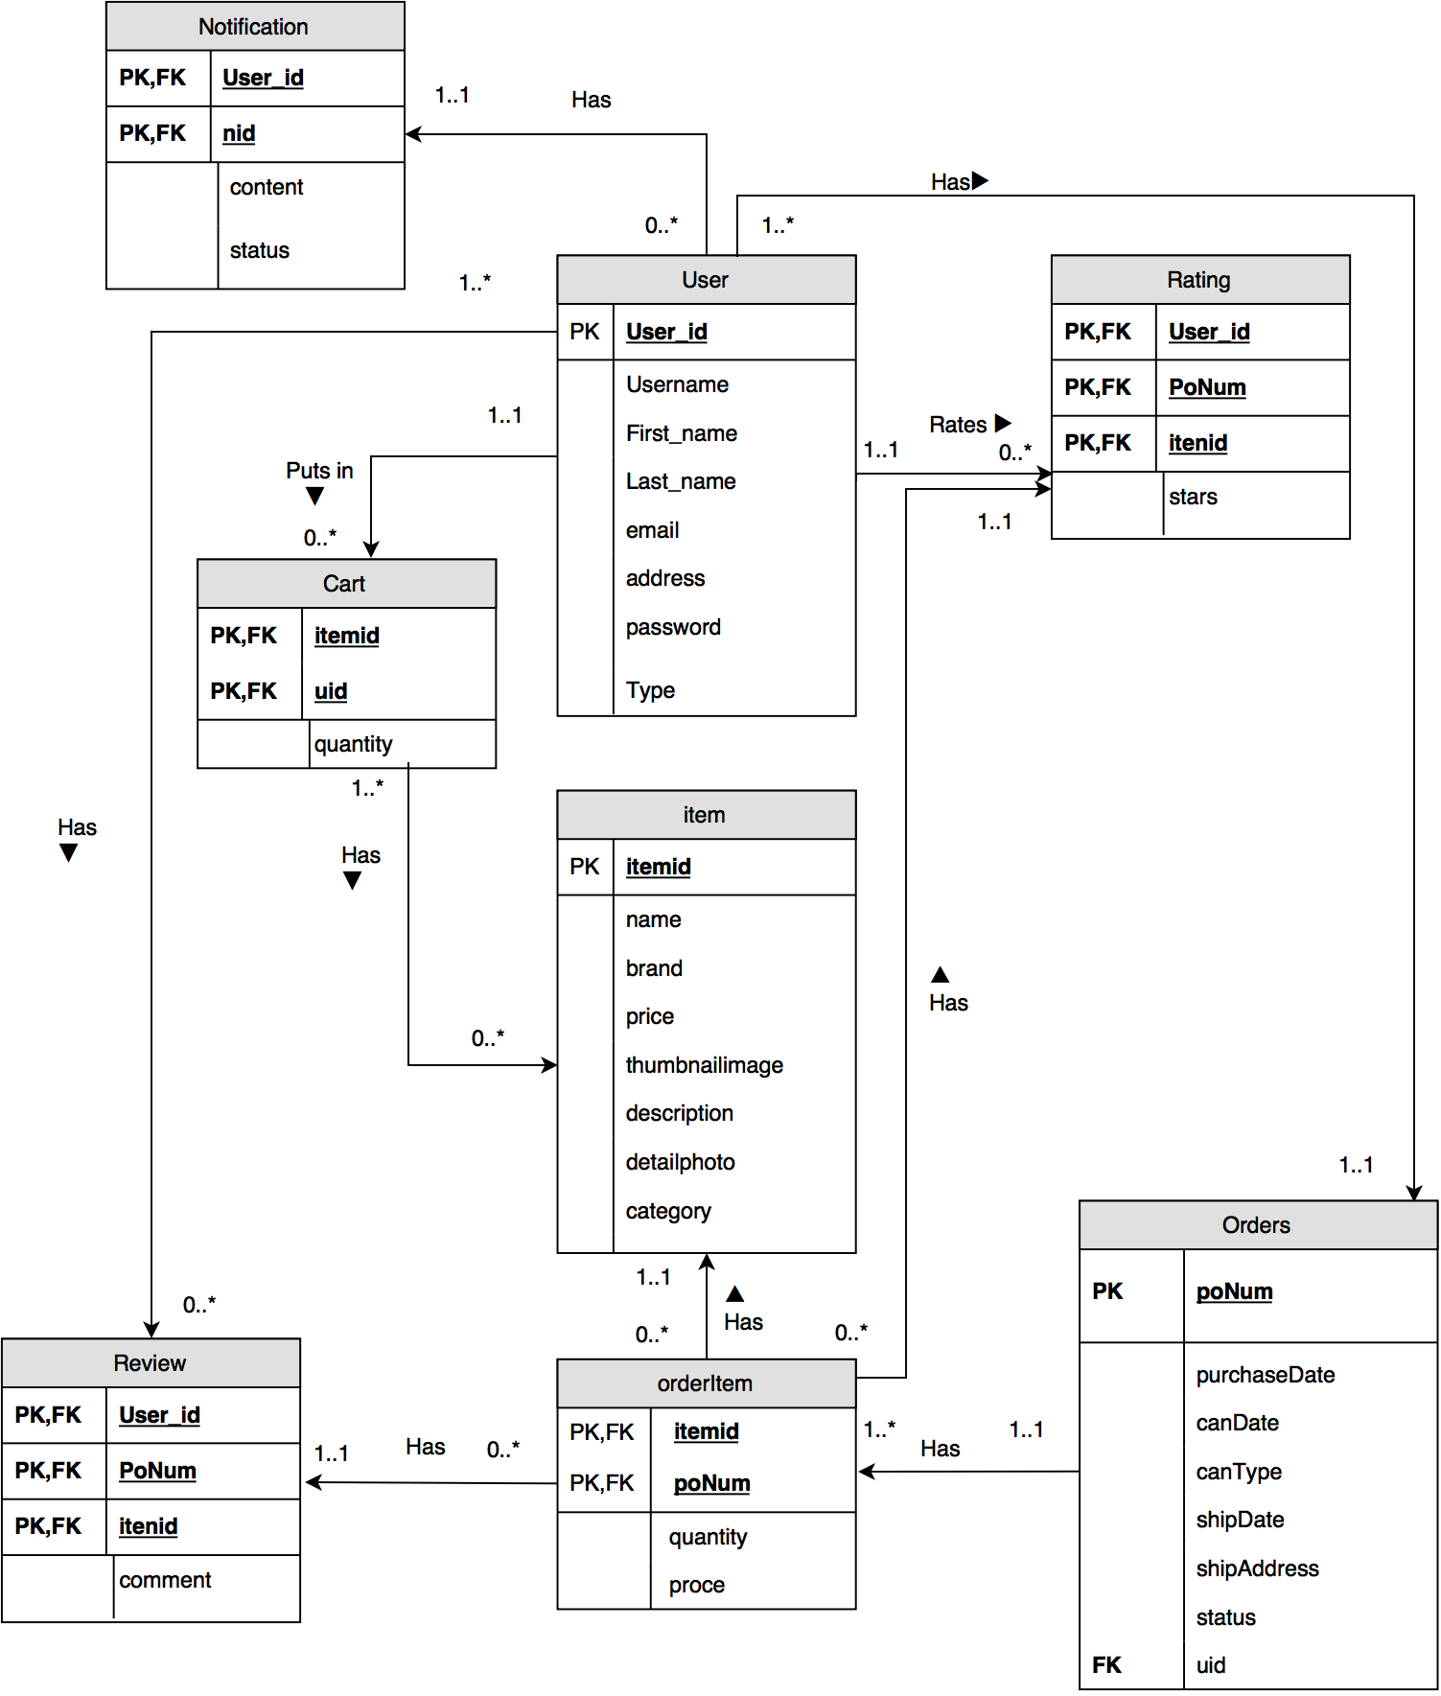

Figure 1 Entity-Relationship Diagram

### Data Structure

The data structure in detail of each table is shown in the following tables. The data type, primary key, and nullability of each field is represented below.

User：

|  |  |  |  |  |
| --- | --- | --- | --- | --- |
| Column | Description | PK | FK | Data Type |
| user\_id | the unique id of user | PK |  | varchar(255) |
| username | user's full name |  |  | varchar(255) |
| first\_name | the first name of user |  |  | varchar(255) |
| last\_name | the last name of user |  |  | varchar(255) |
| email | user's email for sending mails |  |  | varchar(255) |
| address | address that the product send to |  |  | varchar(255) |
| password | the password of user account |  |  | varchar(255) |
| type | is user vendor or customer |  |  | set('vender','customer') |

Table 1: Data Structure (User)

Cart:

|  |  |  |  |  |
| --- | --- | --- | --- | --- |
| Column | Description | PK | FK | Data Type |
| itemid | the unique id of product, foreign key to itemid of item | PK | FK(item\_itemid) | varchar(255) |
| uid | the user id of product in shopping cart, foreign key to user\_id of table user | PK | FK(user\_user\_id) | varchar(255) |
| quantity | the quantity of the product in shopping cart |  |  | int(11) |

Table 2: Data Structure (Cart)

Item:

|  |  |  |  |  |
| --- | --- | --- | --- | --- |
| Column | Description | PK | FK | Data Type |
| itemid | the unique id of product | PK |  | varchar(255) |
| name | the name of product |  |  | varchar(255) |
| brand | the brand of product |  |  | varchar(255) |
| price | the unit price of product |  |  | double(10,0) |
| thumbnailimage | the url of a thumb nail image |  |  | varchar(255) |
| description | list description of product |  |  | text |
| detailphoto | the images of the detail of product |  |  | varchar(255) |
| category | the category of product |  |  | varchar(255) |

Table 3: Data Structure (Item)

OrderItem:

|  |  |  |  |  |
| --- | --- | --- | --- | --- |
| Column | Description | PK | FK | Data Type |
| poNum | the purchase order number, foreign key to poNum in orders | PK |  | varchar(255) |
| itemid | the item id of product in this purchase order, foreign key itemid in item | PK |  | varchar(255) |
| quantity | the quantity of the product in purchase order |  |  | int(11) |
| price | the unit price of product |  |  | double(10,0) |

Table 4: Data Structure (Orderitem)

Rating:

|  |  |  |  |  |
| --- | --- | --- | --- | --- |
| Column | Description | PK | FK | Data Type |
| user\_id | the user id of product in rating, foreign key to user\_id of table user | PK | FK(user\_user\_id) | varchar(255) |
| poNum | the purchase order number, foreign key to poNum in ordersitem | PK | FK(ordersitem\_poNum) | varchar(255) |
| itemid | the unique id of product, foreign key to itemid of orderitem |  | FK(orderitem\_itemid) | varchar(255) |
| stars | the rating score of the product |  |  | int(11) |

Table 5: Data Structure (Rating)

Orders:

|  |  |  |  |  |
| --- | --- | --- | --- | --- |
| Column | Description | PK | FK | Data Type |
| poNum | the purchase order number | PK |  | varchar(255) |
| purchaseDate | the purchase date of the order |  |  | date |
| canDate | the canceled date of the order |  |  | date |
| canType | indicate who cancel the order, vendor or customer |  |  | varchar(255) |
| shipDate | the ship date of order |  |  | date |
| shipAddress | the ship address of order |  |  | varchar(255) |
| status | the status of order, could be pending, hold, shipped, canceled |  |  | set('pending','hold',  'shipped','cancelled') |
| uid | the user id of product in order, foreign key to user\_id of table user | PK | FK(user\_user\_id) | varchar(255) |

Table 6: Data Structure (Orders)

Review:

|  |  |  |  |  |
| --- | --- | --- | --- | --- |
| Column | Description | PK | FK | Data Type |
| user\_id | the user id of product in order, foreign key to user\_id of table user | PK | FK(user\_user\_id) | varchar(255) |
| poNum | the purchase order number, foreign key to poNum in ordersitem | PK | FK(ordersitem\_poNum) | varchar(255) |
| itemid | the unique id of product, foreign key to itemid of orderitem | PK | FK(orderitem\_itemid) | varchar(255) |
| comment | the comment of the product |  |  | text |

Table 7 Data Structure: (Review)

Notification:

|  |  |  |  |  |
| --- | --- | --- | --- | --- |
| Column | Description | PK | FK | Data Type |
| user\_id | the user id of product in order, foreign key to user\_id of table user | PK | FK(user\_user\_id) | int(11) unsigned |
| nid | the unique id of notification | PK |  | int(11) |
| content | the notification content |  |  | text |
| status | the statues of notification. 0 means read. 1 means unread. |  |  | set('1','0') |

Table 8 Data Structure (Notification)

## Dynamic Modeling

### State diagram

This diagram details the transitions or changes of state an order placement process can go through. It begins with an order been placed, and end up with the product been received, reveals all possible transitional states throughout this process, including pending, shipping, hold, cancelled, and received.

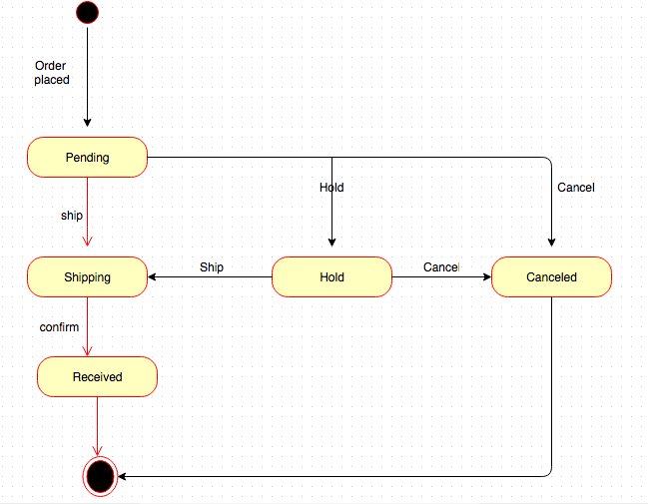

Figure 2 State diagram

### Purchase Activity Diagram

The purchase activity performs the function of illustrating all the possible customer behaviors when they enter the website homepage. Furthermore, it meanwhile shows the possible operations when user enters by vendor.

This diagram integrates the major activities.

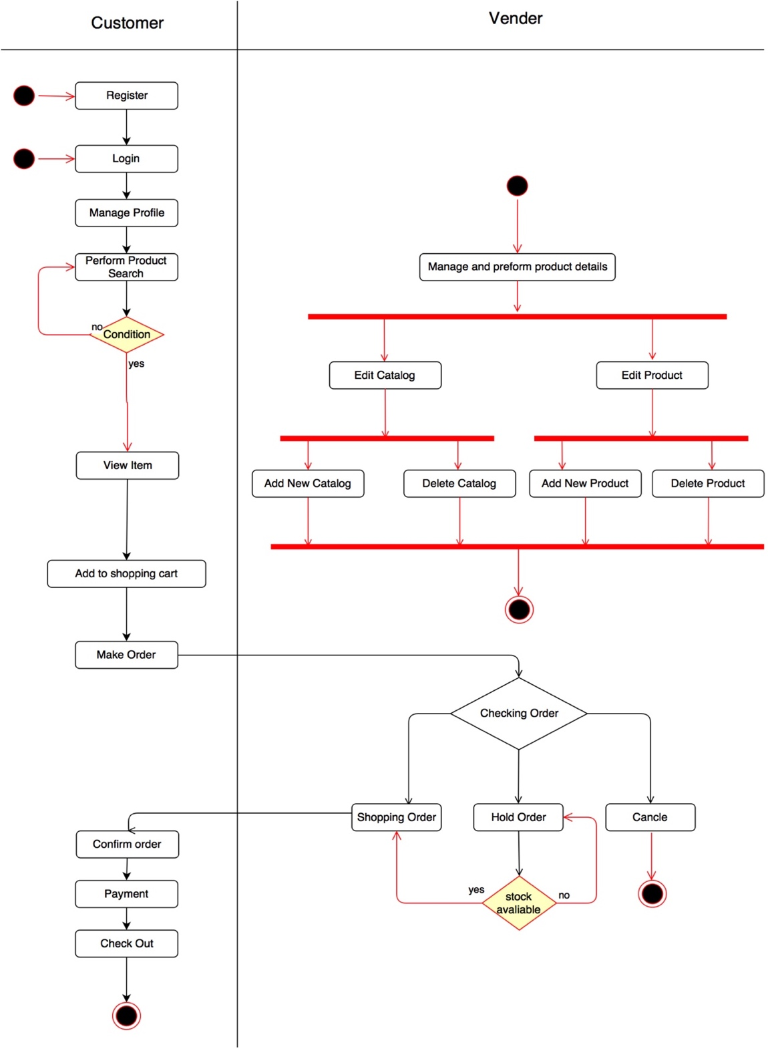

Figure 3 Purchase Activity Diagram

# System Implementation

## Platforms

Focusing on the programing language at the back-end, we use C# as the back ground language. C# (pronounced "C sharp") is a simple, modern, object-oriented, and type-safe programming language. It will immediately be familiar to C and C++ programmers. C# combines the high productivity of Rapid Application Development (RAD) languages and the raw power of C++.

Focusing on the programing language at the front-end, we use HTML5, CSS3, and JavaScript. HTML5 is the fifth revision and newest version of the HTML standard. It offers new features that provide not only rich media support, but also enhance support for creating web applications that can interact with the user, his/her local data, and servers, more easily and effectively than was possible previously.

Focusing on the framework of background, we use .NET framework. .NET is a general purpose development platform. It can be used for any kind of app type or workload where general purpose solutions are used. It has several key features that are attractive to many developers, including automatic memory management and modern programming languages, that make it easier to efficiently build high-quality apps. Multiple implementations of .NET are available, based on open .NET Standards that specify the fundamentals of the platform.

Focusing on the database, we use MySQL. MySQL is a fast, easy-to-use RDBMS being used for many small and big businesses. MySQL is developed, marketed, and supported by MySQL AB, which is a Swedish company. MySQL is becoming so popular because of many good reasons:

* MySQL is released under an open-source license. So you have nothing to pay to use it.
* MySQL is a very powerful program in its own right. It handles a large subset of the functionality of the most expensive and powerful database packages.
* MySQL uses a standard form of the well-known SQL data language.
* MySQL works on many operating systems and with many languages including PHP, PERL, C, C++, JAVA, etc.
* MySQL works very quickly and works well even with large data sets.
* MySQL is very friendly to PHP, the most appreciated language for web development.
* MySQL supports large databases, up to 50 million rows or more in a table. The default file size limit for a table is 4GB, but you can increase this (if your operating system can handle it) to a theoretical limit of 8 million terabytes (TB).

MySQL is customizable. The open-source GPL license allows programmers to modify the MySQL software to fit their own specific environments.

## Architecture

This graph represents the highest level of abstraction of this software system. Including how each module connects to and interacts with others, as well as the functionality of each module.

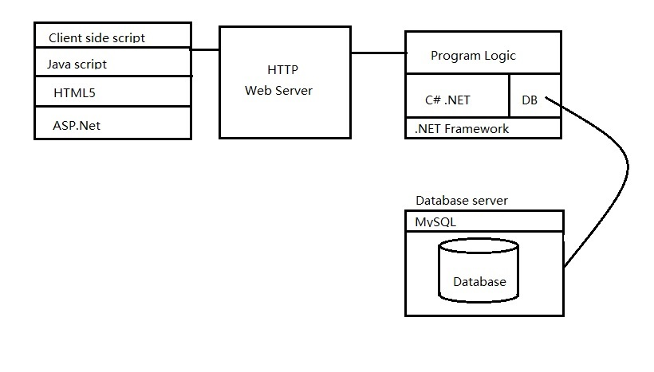

Figure 4 Abstraction architecture of system

## Module Design

The website system is the combination of six separate components, which are shown below:

1. Account

User registration, log in and log out.

*Register\_Page.Button1\_Click* is responsible for user registration. *Login\_Page.Button1\_Click* is responsible for user log in and log out.

1. Brand

Filter the product

*Product\_page.Button2\_Click* is responsible for filter the product.

1. Product

Product detail information.

*Product\_page* is the core module. *Product\_page.showproduct* is responsible for list the information of product. *Product\_page.Gridview2\_Sorting* is responsible for sorting the products. *Product\_page.GridView1\_PageIndexChanging Prodct\_page.pre\_Click* and *Prodct\_page.next\_Click* are responsible for paging the prodct.

*ProductDetail\_page* is resoniple for showing the detail information of product.

1. Shopping cart

Add or delete item, change the quantity of item.

*ShoppingCart\_Page* is the core module. *ProductDetail\_page.Button2\_Click* is responsible for adding item. *ShoppingCart\_Page.Repeater1\_ItemCommand* is responsible for deleting item and changing the quantity of item.

1. Order

Check out.

*Purchase\_Tracking\_Page* is the core module. *Purchase\_Tracking\_Page.Button2\_Click1* is responsible for checking out.

1. Vendor operation

Add or edit products, cancel the order.

*Vendor\_page* is the core module. *Vendor\_page\_order.addproduct.click is responsible for adding new product.*

*Vendor\_page\_order.pendingtoshipped.click Vendor\_page\_order.pendingtohold\_click and Vendor\_page\_order.holdtoshiped\_click* are responsible for changing the order status. *Vendor\_page\_order.cancel\_click is responsible for* cancelling the order.

## Project Outcome

### Home page

This is the home page of our website.

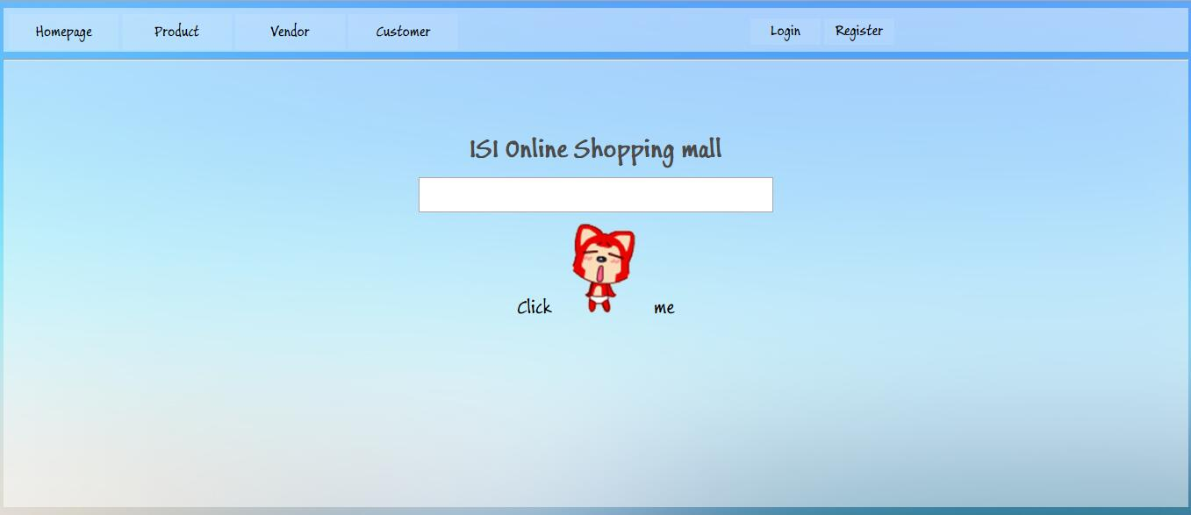

Figure 5 Home Page

### Register and log in

Fill in the form with all the necessary information to accomplish the registration process.

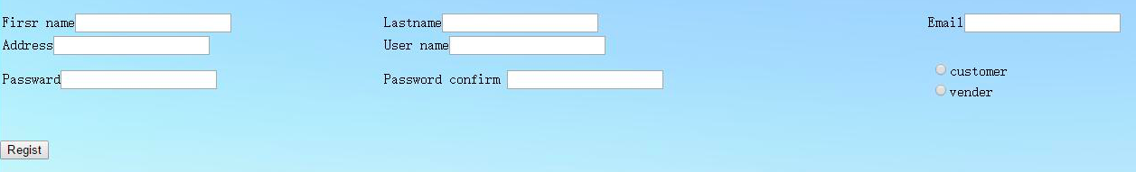

Figure 6 Register Page

Customer log in page:

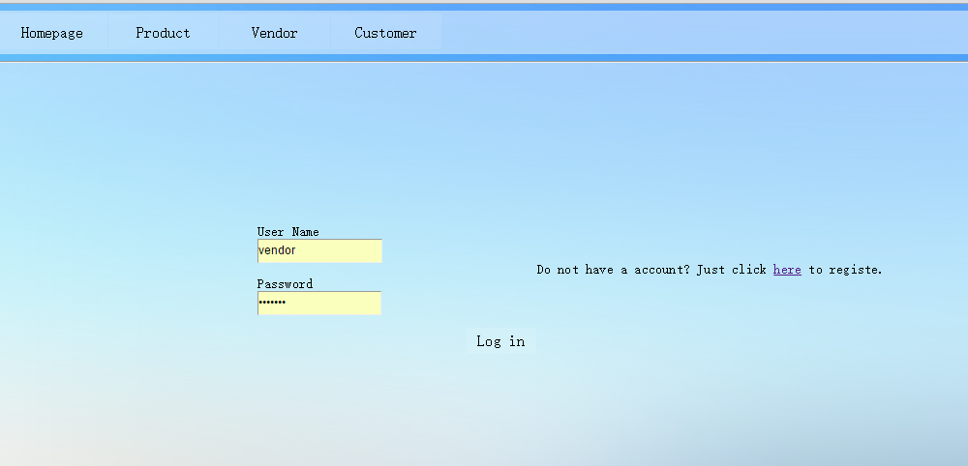

Figure 7 Log In Page

### purchasing product

Purchasing a product by first adding it to the shopping cart:

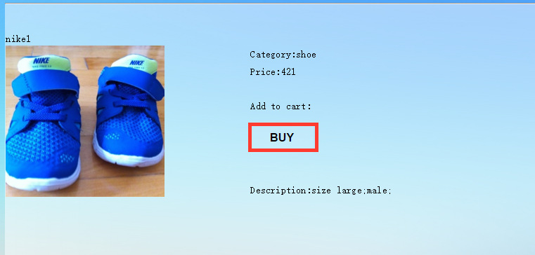

Click this button,

this product will

add into cart

Figure 8 Add product to shopping cart

Go to the shopping cart. Modification on the quantity of each product is available in the shopping cart.

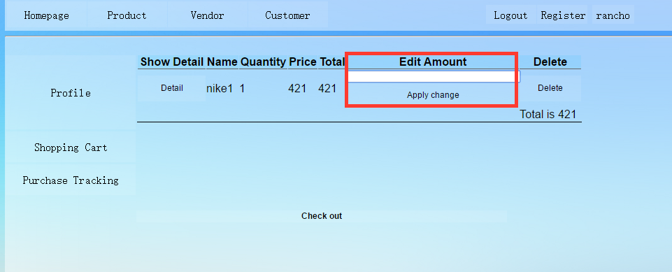

Figure 9 Change Product Quantity I

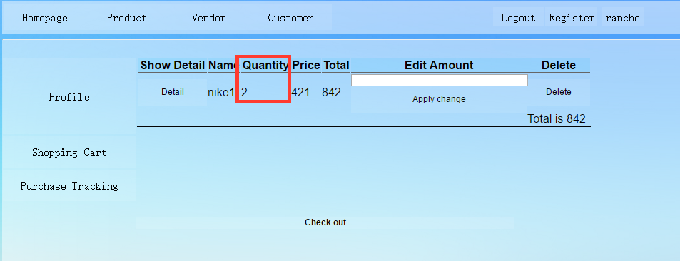

Figure 10 Change Product Quantity II

Accomplishing the whole purchasing process customer need to comment the product.

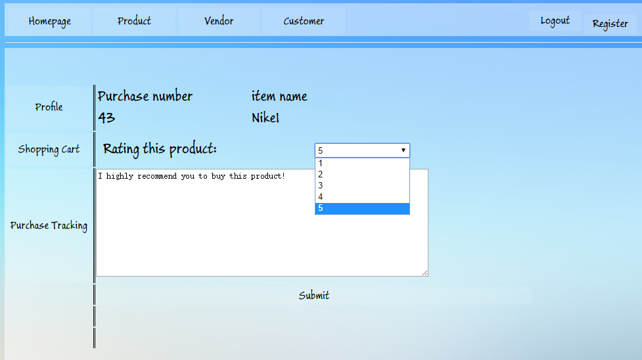

Figure 11 Leave commend

### Vendor Page

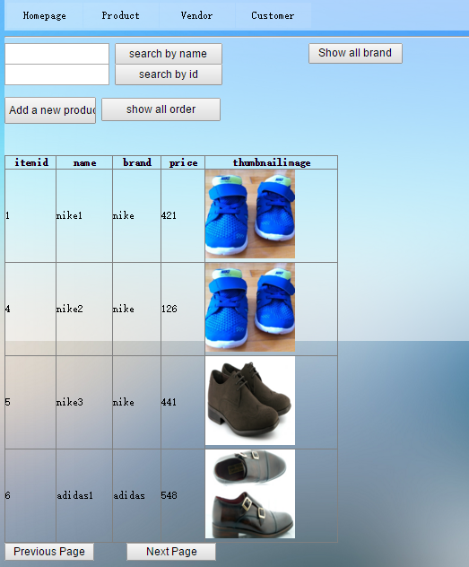

Figure 12 Vendor page

Add a new product

Add a new product

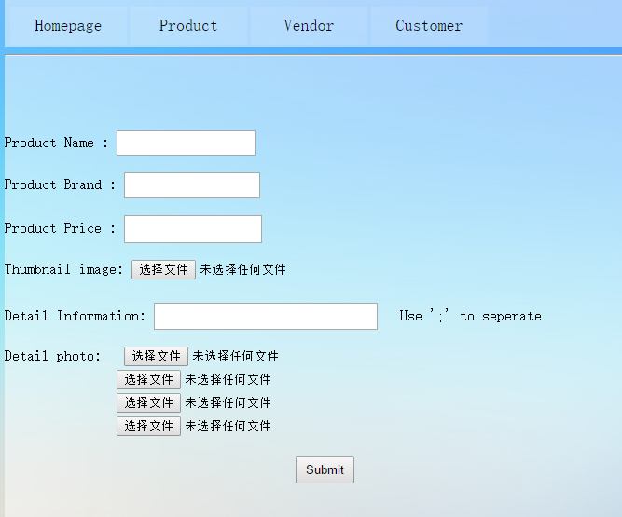

Figure 13 Add new product

This page shows the details of product

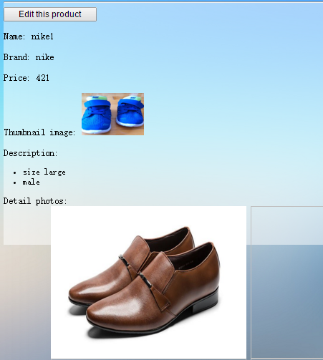

Figure 14 Detail page for vendor

Edit the details of product

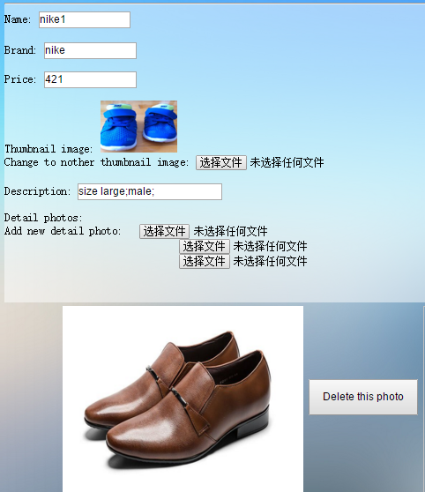

Figure 15 Edit information

Click change the status from pending to shipped

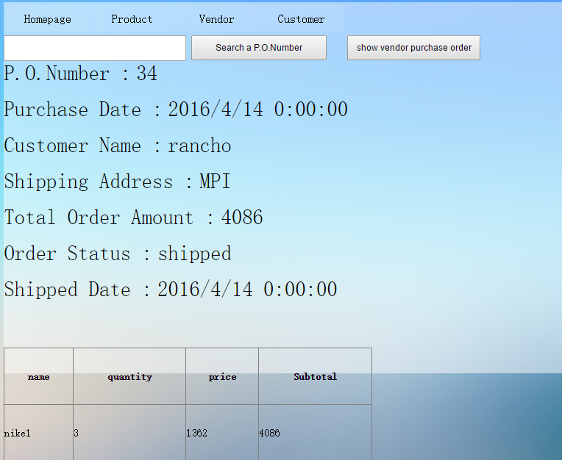

Figure 16 Pending to shipped

Click the order is out-of-stock

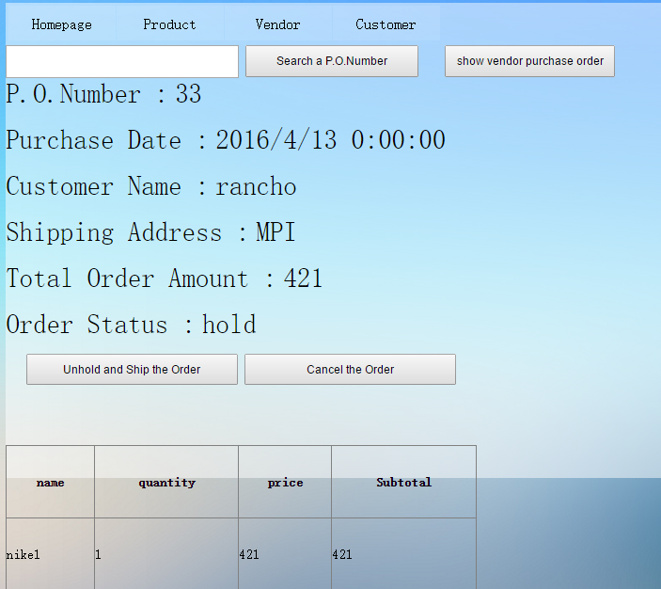

Figure 17 out of stock

Click cancel the order

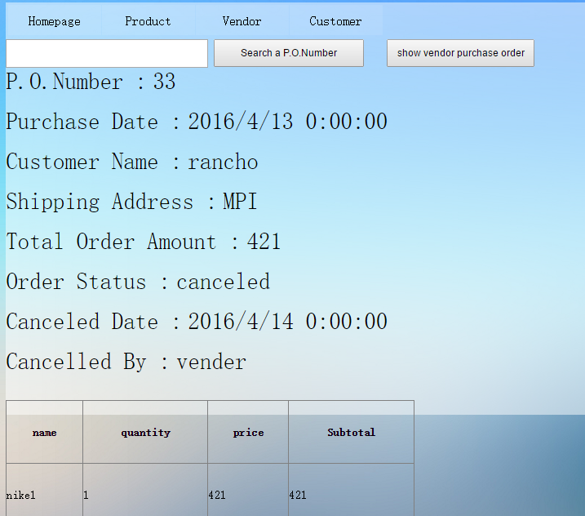

Figure 18 Cancel order

## Testing

Product list

|  |  |
| --- | --- |
| Test case name | Browse products and paging |
| Test requirement No. | A1, A2 |
| Description of test case | A customer may browse products in a list supported paging of the existing product categories |
| Module | Product |
| Pre-condition |  |
| Step & Result | Click the page down or page up button, this website will display next page ot last page.  Entire specific page number, this website will display specific page. |

Table 9 Testing (Browse products and paging)

|  |  |
| --- | --- |
| Test case name | Filter or search product and sort product |
| Test requirement No. | A3, A4, A5 |
| Description of test case | Customer may filter the product list by searching keywords or brand, and order the product list by price. |
| Module | Product |
| Pre-condition |  |
| Step & Result | Entire the keyword and click the search button. This website filters the product list.  Click on the price label, this website will sort the product list based on price. |

Table 10 Testing (Filter or search product and sort product)

|  |  |
| --- | --- |
| Test case name | Show product detail |
| Test requirement No. | A6, A7 |
| Description of test case | Customer can browse the detail information of product. |
| Module | Product |
| Pre-condition |  |
| Step & Result | Click on the show details button, the website will redirect to the product detail page and list the information. |

Table 11 Testing (Show product detail)

Registration and login

|  |  |
| --- | --- |
| Test case name | Duplicate user name |
| Test requirement No. | B1 |
| Description of test case | User ID may already be used when creating a new account |
| Module | Account |
| Pre-condition | User name “Tiny\_Ho” has been used |
| Step & Result | When a user create a new account, he enters “Tiny\_Ho” as his user name, the system displays a message about the name has been used. |

Table 12 Testing (Duplicate user name)

|  |  |
| --- | --- |
| Test case name | Access deny for anonymous user |
| Test requirement No. | B2, B4 |
| Description of test case | User must log in order to visit the shopping cart and purchase tracking and purchase item |
| Module | Account |
| Pre-condition | User has not logged in. |
| Step & Result | When user try to visit the shopping cart and purchase tracking or buy product without log in. The website will redirected to log in page. |

Table 13 Testing (Access deny for anonymous user)

|  |  |
| --- | --- |
| Test case name | The password is not in requirement form |
| Test requirement No. | B3 |
| Description of test case | When people registered a new account he should enter a password contain at least 6 characters, in which there are at least 1 digit and 1 capital letter. |
| Module | Account |
| Pre-condition |  |
| Step & Result | When a user create a new account, he enters “asdf123” as his user password, the system displays a message about the password is not allowed. |

Table 14 Testing(Wrong form password)

|  |  |
| --- | --- |
| Test case name | Missing some required information when registration |
| Test requirement No. | B1 |
| Description of test case | User forgets to fill in required information such as first name, e-mail address, address and etc. |
| Module | Account |
| Pre-condition |  |
| Step & Result | Leaving a field empty, then click confirm, the system will remind user that he has to complete the information. |

Table 15 Testing(Missing information)

|  |  |
| --- | --- |
| Test case name | Wrong information in user login |
| Test requirement No. | B |
| Description of test case | User type a wrong username or password |
| Module | Account |
| Pre-condition |  |
| Step & Result | User enter username and password, then click login, the system displays a message that the username or password is wrong. |

Table 16 Testing(User login)

Purchase

|  |  |
| --- | --- |
| Test case name | Shopping cart |
| Test requirement No. | C1, C2, C3, C4, C5 |
| Description of test case | User can browse the shopping cart and change the quantity of each product |
| Module | Purchasing |
| Pre-condition | Add “nike1” in the shopping cart |
| Step & Result | User click the show detail button of nike1, website redirects to product detail page of nike1. User enter the quantity he want in shopping cart and click apply change button, the quantity of nike1 will change to number user want. |

Table 17 Testing (Shopping cart)

|  |  |
| --- | --- |
| Test case name | Customer adds a duplicate product |
| Test requirement No. | C6 |
| Description of test case | Add duplicate products in the shopping cart. |
| Module | Purchasing |
| Pre-condition | Add “nike1” in the shopping cart |
| Step & Result | Select “nike1” then click buy, system will displays a message that this product has already in the shopping cart. |

Table 18 Testing(Add duplicate product)

|  |  |
| --- | --- |
| Test case name | Purchase order |
| Test requirement No. | D1, D2, D3 |
| Description of test case | User can browse the list of purchase and view the detail information of each one. User can also filter the purchase list based on statues. |
| Module | Purchasing |
| Pre-condition | Check out the items in shopping cart. |
| Step & Result | Click the purchase row, website redirects to purchase detail page. Click the filter option button, website display the “current purchases” or “past purchases” |

Table 19 Testing (Purchase order)

|  |  |
| --- | --- |
| Test case name | Cancel purchase order |
| Test requirement No. | D4 |
| Description of test case | User can only cancel the order when it is “pending” or “holding”. |
| Module | Purchasing |
| Pre-condition | Vendor has already change order statues to “shipped”. |
| Step & Result | User click the cancel button in purchase detail page. This action cannot be accomplished. |

Table 20 Testing (Cancel purchase order)

Vendor

|  |  |
| --- | --- |
| Test case name | Vendor can search product |
| Test requirement No. | E1, E2 |
| Description of test case | Vendor can browse the product catalog and search item. |
| Module | Vendor operation |
| Pre-condition |  |
| Step & Result | Vendor browses the catalog and enters the key word, clicks on the search button. Website will filter the product |

Table 21 Testing (Vendor can search product)

|  |  |
| --- | --- |
| Test case name | Missing information when add new product |
| Test requirement No. | E3, E4 |
| Description of test case | Vendor add new product without enter some necessary. |
| Module | Vendor operation |
| Pre-condition |  |
| Step & Result | Vendor add to new product without entering price. When click the add button, the alarm message will appear and this action will not be accomplished. |

Table 22 Testing (Missing information when add new product)

|  |  |
| --- | --- |
| Test case name | Edit information of product |
| Test requirement No. | E5, E6 |
| Description of test case | Vendor edit product without enter some necessary. |
| Module | Vendor operation |
| Pre-condition |  |
| Step & Result | Vendor add product without entering price. When click the confirm button, the alarm message will appear and this action will not be accomplished. |

Table 23 Testing (Edit information of product)

|  |  |
| --- | --- |
| Test case name | Vendor browses purchase order |
| Test requirement No. | F1, F2 |
| Description of test case | Vendor can browse the list of purchase. Vendor can also filter the purchase list based on statues. |
| Module | Vendor operation |
| Pre-condition | Check out the items in shopping cart. |
| Step & Result | Click the filter option button, website display the “pending orders”, “orders on hold” and “past orders” |

Table 24 Testing (Vendor browses purchase order)

|  |  |
| --- | --- |
| Test case name | Vendor change purchase statues |
| Test requirement No. | F3, F4. F5, F6 |
| Description of test case | Vendor can change the statues of purchase. |
| Module | Vendor operation |
| Pre-condition | Check out the items in shopping cart. |
| Step & Result | After entering purchase order processing page, vendor click button for changing statues. The statues of order will be changed to the corresponding one. |

Table 25 Testing (Vendor change purchase statues)

|  |  |
| --- | --- |
| Test case name | Vendor change purchase statues |
| Test requirement No. | F3, F4. F5, F6 |
| Description of test case | Vendor can change the statues of purchase. |
| Module | Vendor operation |
| Pre-condition | Check out the items in shopping cart. |
| Step & Result | After entering purchase order processing page, vendor click button for changing statues. The statues of order will be changed to the corresponding one. |

Table 26 Testing (Vendor change purchase statues)

|  |  |
| --- | --- |
| Test case name | Analyze report |
| Test requirement No. | Z1 |
| Description of test case | The vendor can analyze the sales of the products and find out the best selling products. |
| Module | Vendor operation |
| Pre-condition |  |
| Step & Result | Vendor enter the report page. Website shows the sales quantities and sales amount within last 30 days. |

Table 27 Testing (Analyze report)

|  |  |
| --- | --- |
| Test case name | Notification |
| Test requirement No. | Z2 |
| Description of test case | Use can get notification when statues of purchase orders change |
| Module | Account |
| Pre-condition | Check out the items in shopping cart. |
| Step & Result | Vendor change the order statues from “pending” to “hold”. User can see notification label. After entering notation page, user can read notification. |

Table 28 Testing (Notification)

|  |  |
| --- | --- |
| Test case name | Rating |
| Test requirement No. | Z3, Z4 |
| Description of test case | User can rate item and write review in purchase order. |
| Module | Product |
| Pre-condition | User purchase successfully. |
| Step & Result | User writes review and rate. Other user enter the product details page will see the review and average rating. |

Table 29 Testing (Rating)

|  |  |
| --- | --- |
| Test case name | Price change |
| Test requirement No. | Z5 |
| Description of test case | Vendor can change the price of product |
| Module | Vendor operation |
| Pre-condition | Check out the items in shopping cart. |
| Step & Result | Vendor change the price of nike1. User check the shopping cart. Nike1 in shopping cart will be affected. User check the purchase order. Nike1 in purchase order will not be affected. |

Table 30 Testing (Price change)

# Conclusion and Further Work

## Conclusion

The project began with an investigation of the current market analysis, examining the mainstream competitors and their advantages. It helped us determine our major products to sell, as well as assisted us to develop better interface and user-friendly interactions.

Our development strictly follows the requirement list, among all these 42 requirements, we accomplished 40 of them. All the compulsory requirements are carefully carried out and checked.

The data of products and business transactions are stored in MySQL database, the whole software system contains 8 tables, user, cart, item, orderitem, orders, rating, review and notification. They are properly linked to each other, in order to support the account management and execution of business transactions.

## Further Work

In the future, we want to ingest more functions through evaluating other e-business website, like Taobao and JD. More flexible category management is the primary goal we want to improve, cause to provide users with better and more convenient user experience is what we have been insisted on.

Concerning about the payment part, domestic widely-used payment methods will be fully supported in ISI store, such as E-bank, UnionPay, and Alipay. Simultaneously, world-renowned payment, such as Paypal will also be available. In order to embed these online payment systems, one of the most crucial pre-requisites is security, some modules, especially account, order, and product management must be reinforced.

Last but not least, we also plan to optimize each module and database for the sake of better robustness and shorter interaction responses in practical application.

# References

[1] E-commerce, (n.d.). In Wikipedia. Retrieved March 3, 2015,

From http://en.wikipedia.org/wiki/E-commerce, 2015.

[2] CHINA RETAIL Shopping malls in China - China’s commercial property hot spot as consumer preferences shift. Fung Business Intelligence Centre, October 2014.

[3] Introduction (c#)

From <https://msdn.microsoft.com/en-us/library/aa645597(v=vs.71).aspx> ,2016

[4] HTML5

From <https://en.wikipedia.org/wiki/HTML5>

[5] .NET Development

From <https://msdn.microsoft.com/en-us/library/ff361664(v=vs.110).aspx>

[6] MySQL Introduction

From <http://www.tutorialspoint.com/mysql/mysql-introduction.htm>

[7] MySQL - Getting started

From http://asp.net-tutorials.com/mysql/getting-started/

# Appendix

## Project plan

Gantt Chart

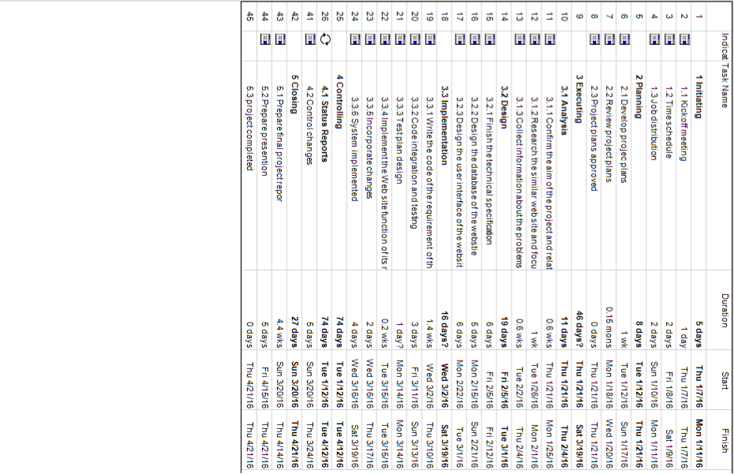

Figure 19 Gantt Chart Part I

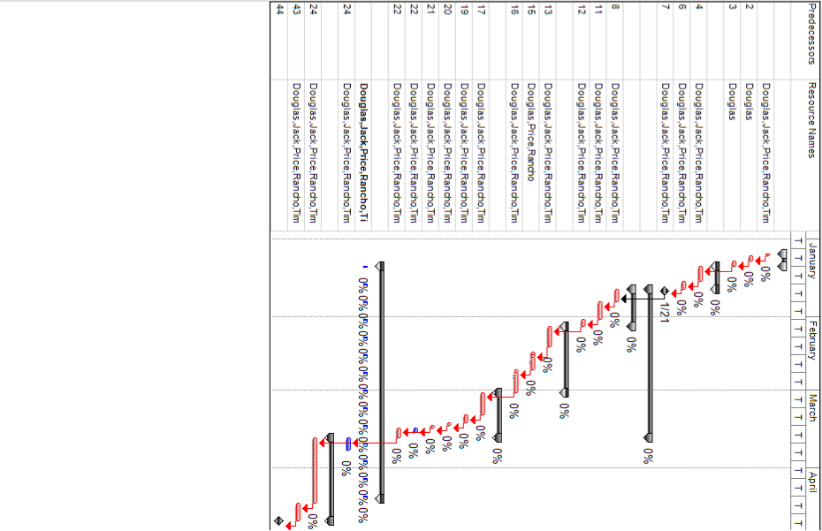

Figure 20 Gantt Chart Part II

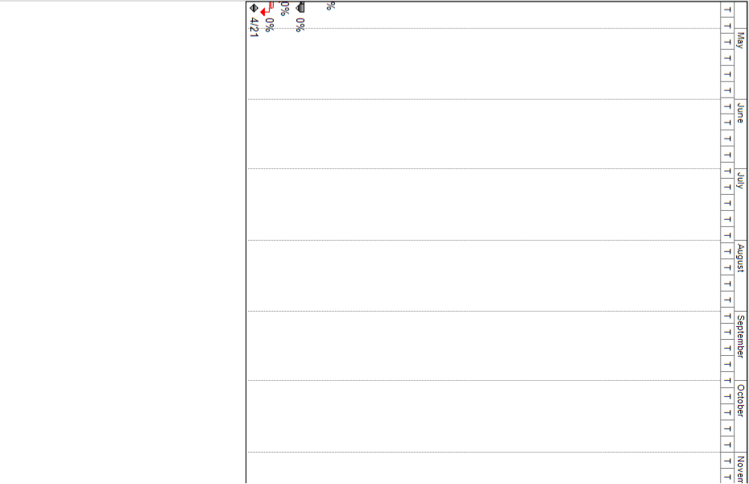

Figure 21 Gantt Chart Part III

## Team Members

P1308512 Douglas, Team leader

P1307696 Rancho

P1307677 Tim

P1307658 Price

P1207933 Jack

## Job Distribution

### Function requirement

Function requirement A & Z1: Jack

Function requirement B & F1 & F2 & Z2: Tim

Function requirement C & F3 & Z3: Douglas

Function requirement D & F4 & F5 & F6 & Z4: Rancho

Function requirement E & F7 & Z5: Price

### Technical specification

ER diagram: Rancho & Price

User case: Douglas

Architecture design: Rancho

Activities diagram: Jack

State diagram: Tim

### Other jobs

Research study: Price

Report writing: Douglas

Project coordination: Douglas}

## Peer Assessment Form

|  |  |  |  |  |  |  |
| --- | --- | --- | --- | --- | --- | --- |
| S:\3rd ITC\2nd ITC\MPI_logos\MPI logo09_C349 CPE.tif  BSc. in Computing 2015/16  COMP321 Information System Implementation  Peer Assessment Form | | | | | | |
| Group number | 8 | | | | | |
| Group members | |  |  |  | | --- | --- | --- | |  | Student ID | Student name | | *1.* | P1308512 | Douglas | | *2.* | P1307696 | Rancho | | *3.* | P1307677 | Tim | | *4.* | P1307658 | Price | | 5. | P1207933 | Jack | | | | | | |
| Contribution **(**Each row must total to 100%) | | | | | | |
|  | | Member 1 | Member 2 | Member 3 | Member 4 | Member 5 |
| 1. Project leadership | | 25% | 20% | 20% | 20% | 15% |
| 2. Data modeling | | 25% | 22% | 18% | 20% | 15% |
| 3. User interface design | | 20% | 25% | 20% | 20% | 15% |
| 4. Program development | | 24% | 24% | 15% | 22% | 15% |
| 5. Solving technical problems | | 25% | 20% | 20% | 20% | 15% |
| 6. Testing and sample data | | 25% | 25% | 17% | 18% | 15% |
| 7. Report writing | | 25% | 17% | 25% | 18% | 15% |
| 8. Preparing / giving presentation | | 25% | 18% | 23% | 19% | 15% |

By default, the eight items above have the same weight when calculating the overall contribution percentage. You are welcome to suggest different weight if you consider some aspects should carry more weight.